MSc Bioinformatics and Computational Biology
MB6303 - Guidelines for Research Project Marking

MSc Degree Award criteria:
A student who obtains an average mark of at least 50% across the taught modules,
and not less than 40% in the Research Dissertation (MB6303), will be eligible for the
award of the MSc degree. A student who does not attain 40% in the Research Dissertation (MB6303) will graduate with a Postgraduate Diploma.

For 70% of the final mark will come from an assessment by the Supervisor and 30% from an assessment by a Second Internal Examiner of the written reports and the seminar.

1. Computational Work (40%, assessment by the Supervisor)
(a) Intellectual mastery and responsibility;
(b) Understanding of background and synthesis of new ideas;
(c) Provision of their own ideas for the project;
(d) Critical thinking and evaluation of data;
(e) Effort and competence.

Mark awarded as follows:
90+ Outstanding in all five categories. Publishable with no changes
80+ Outstanding in all five categories. Publishable with minor changes
70-79 Excellent in all five categories; with clear evidence for criterion (a).
66-69 Excellent in (b) and (c) and very good in (d) and (e).
61-65 Very good overall and excellent in one of (b), (c) or (d).
55-60 Good overall and very good in one of (c), (d) or (e).
50-54 Adequate overall.
40-49 Mostly adequate but important deficiencies.
< 40 Fail. Overall effort totally inadequate.

2. Project Reports (50%: 25% each from the Supervisor and 2nd Reader)

Literature Review (Introduction):
(a) Clear demonstration of understanding of the relevant literature;
(b) Selection of appropriate papers;
(c) Summary of the topic in a succinct, clearly readable form.

Mark for Literature Review will be awarded as follows:
90+ Outstanding in all three categories. Publishable with no changes
80+ Outstanding in all three categories. Publishable with minor changes
70-79 Excellent in all three categories; with clear evidence for criterion (a).
66-69 Excellent in all three categories; with clear evidence for criterion (b).
61-65 Very good overall and good in of one of (b), or (c).
55-60 Good overall.
50-54 Adequate overall.
40-49 Mostly adequate but important deficiencies.
< 40 Fail. Overall effort totally inadequate.

Final Report:
Methods (a) A clear description of the methods used, by citation alone, or citation plus modifications employed;
Results (b) Presentation of data in suitable format, including statistical analysis where appropriate;
Discussion (c) Evaluation of data quality, robustness, significance;
(d) Quality of interpretations and conclusions drawn directly from the data;
(e) Comparison with the literature where appropriate;
(f) Evaluation of whether the initial goas were achieved, and if not, why.

Mark for Final Report will be awarded as follows:
90+ Outstanding in all six categories. Publishable with no changes
80+ Outstanding in all six categories. Publishable with minor changes
70-79 Excellent in all six categories.
66-69 Excellent in four categories; and very good in two others.
61-65 Very good overall.
55-60 Good overall.
50-54 Adequate overall.
40-49 Mostly adequate but important deficiencies.
< 40 Fail. Overall effort totally inadequate.

Seminar Presentation (10%: 5% each from the Supervisor and 2nd Reader)
Overall, 60% of the marks come from Content and 40% from Presentation.
Criteria to be assessed by Supervisor and Second Examiner:

1. Content
(i) Factual accuracy;
(ii) Scientific approach;
(iii) Handling of questions.

2. Presentation
(iv) Ease of understanding;
(v) Logical ordering;
(vi) Quality/use of visual aids;
(vii) Time-keeping;
(viii) Style of presentation (read, notes or noteless);
(ix) Clarity of delivery.
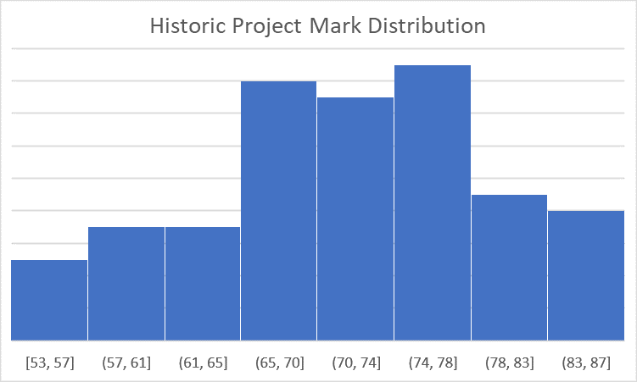
Mark for Seminar Presentations will be awarded as follows:
80+ Outstanding overall.
70-79 Excellent overall.
66-69 Very good overall.
61-65 Good overall.
55-60 Good overall, but deficiencies in content.
50-54 Adequate overall.
40-49 Mostly adequate but important deficiencies.
< 40 Fail. Overall effort totally inadequate.

MSc Bioinformatics - MB6303 Project
Grading Scheme

Student Name: No:
Supervisor:

Project Title:

Supervisors Report (70% of grade)

Laboratory Work (40% of grade)

Comments:

Mark out of 40

Project Report (25%)
a) Literature review (10%)
Comments:

Mark out of 10
b) Final Report: (15%)
Comments:

Mark out of 15

Oral Presentation (5%)
Comments:

Mark out of 5
Grade out of 70%: Overall Grade out of 100%:

MSc Bioinformatics - MB6303 Project
Grading Scheme

Student Name: No:

Second Reader:

Second Readers Report (30% of grade)

Project Report (25%)
a) Literature review (10%)
Comments:

Mark out of 10
b) Final Report: (15%)
Comments:

Mark out of 15

Oral Presentation (5%)
Comments:

Mark out of 5

Overall Grade out of 30%:

